Name: ____________________________________

NetID: ____________________________________

Discussion section: __________________________

**LING 1010 – Week 7**

**Make-up Assignment**

1. Look at these four sets of colored bars. Imagine that your task is to learn the rule that generates sets of three colored bars. This is like language acquisition (where your task is to learn the rules that generate words and sentences), but a simpler.

1 2 3 4

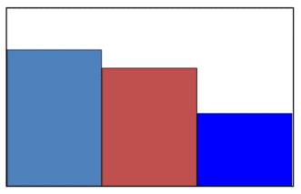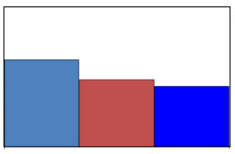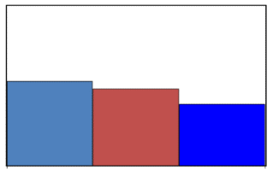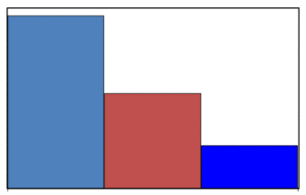

1. Write a rule that generates the four sets of colored bars above:
2. Are the four sets of colored bars above positive evidence or negative evidence?
3. Write a different rule that generates the four sets of colored bars above:
4. What if I told you that this set of bars (#5) is ALSO generated by the rule. What rule do you think it is now?

5

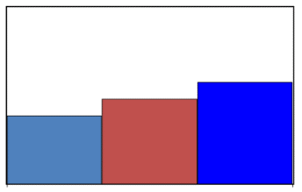

1. And finally, what if I told you that this set of bars (#6) is NOT generated by the rule. What rule do you think it is now?

6

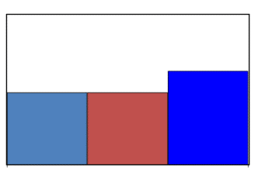

1. What kind of evidence did I just give you in question E?
2. Suppose a friend of yours has a child who is three years old. Your friend has been explaining to you that their child has a problem with forming the past tense of certain verbs. For example, the child says “Yesterday I goed to the park” and “Last week I swimmed in the pool.” But your friend has a plan: spend one hour each day with the child, trying to get the child to produce past tense verbs, and correcting the child whenever the form is incorrect.
3. What kind of evidence is your friend trying to give the child?
4. Will your friend’s plan work? Explain why or why not?
5. What would you tell your friend to do instead, based on what we learned in class
6. The following statements are the five parts of the logical problem of language acquisition. Please provide at least one piece of evidence (or logical argument) for each part.
7. All human languages can be characterized as ***an infinite set*** of sentences:
8. The input that children receive when learning their language is ***finite***:
9. All children ***succeed*** in learning language:
10. ***Negative evidence*** would guarantee that the infinite set can be learned:
11. But children do ***not*** make use of negative evidence:
12. Children appear to be born with the ability to discriminate every sound difference found in human languages. They are universal listeners. Now suppose an infant needs to learn Mandarin (the standard language spoken in China, especially North China). The vowels for Mandarin are given in (a). The vowel space of a universal listener is given in (b). There are boundary lines in (b) for every vowel in the world’s languages, including many vowels that are not in Mandarin. After a year of linguistic input, the infant learns to only discriminate the Mandarin vowels. **Your task is to mimic this process by removing the vowels that are NOT part of Mandarin, and removing the unnecessary boundaries, leaving only the boundaries that are necessary for the Mandarin vowels.** You can do this by literally clicking and deleting the vowels and lines.
13. Mandarin vowels: /i/, /y/, /ɨ/, /u/, /ɚ/, /ɛ/, /ɤ/, /o/, /a/
14. Universal listener vowel space:

i y ɨ [ʉ](https://en.wikipedia.org/wiki/Close_central_rounded_vowel) [ɯ](https://en.wikipedia.org/wiki/Close_back_unrounded_vowel) [u](https://en.wikipedia.org/wiki/Close_back_rounded_vowel)

[ɪ](https://en.wikipedia.org/wiki/Near-close_near-front_unrounded_vowel) [ʏ](https://en.wikipedia.org/wiki/Near-close_near-front_rounded_vowel) [ʊ](https://en.wikipedia.org/wiki/Near-close_near-back_rounded_vowel)

e [ø](https://en.wikipedia.org/wiki/Close-mid_front_rounded_vowel) [ɘ](https://en.wikipedia.org/wiki/Close-mid_central_unrounded_vowel) [ɵ](https://en.wikipedia.org/wiki/Close-mid_central_rounded_vowel) [ɤ](https://en.wikipedia.org/wiki/Close-mid_back_unrounded_vowel) [o](https://en.wikipedia.org/wiki/Close-mid_back_rounded_vowel)

[ə](https://en.wikipedia.org/wiki/Mid_central_vowel#Mid_central_unrounded_vowel)

[ɛ](https://en.wikipedia.org/wiki/Open-mid_front_unrounded_vowel) [œ](https://en.wikipedia.org/wiki/Open-mid_front_rounded_vowel) [ɜ](https://en.wikipedia.org/wiki/Open-mid_central_unrounded_vowel) [ɞ](https://en.wikipedia.org/wiki/Open-mid_central_rounded_vowel) [ʌ](https://en.wikipedia.org/wiki/Open-mid_back_unrounded_vowel) [ɔ](https://en.wikipedia.org/wiki/Open-mid_back_rounded_vowel)

[æ](https://en.wikipedia.org/wiki/Near-open_front_unrounded_vowel) [ɐ](https://en.wikipedia.org/wiki/Near-open_central_unrounded_vowel)

[a](https://en.wikipedia.org/wiki/Open_front_unrounded_vowel) [ɶ](https://en.wikipedia.org/wiki/Open_front_rounded_vowel) [ɑ](https://en.wikipedia.org/wiki/Open_back_unrounded_vowel) [ɒ](https://en.wikipedia.org/wiki/Open_back_rounded_vowel)

1. For each statement below, indicate if the statement is true or false, and explain why.
2. A Chinese child adopted soon after birth by a Danish family will learn Danish more slowly than other children growing up in Denmark with Danish parents because the child is genetically predisposed to learn Chinese.
3. Children say things like *foots* and *both mans* before they master the correct forms *feet* and *both men* because they overuse the rule for regular plural formation.

1. Consider the examples from children’s speech below. Using the linguistic terminology you have learned so far, explain what mistakes the children are making. Be as specific as possible. The examples are taken from Jay (2003), Carroll (2004), and Yule (1996).
2. Patrick: Where are you going?

Tim: I have to go back to Miami.

Patrick: [to his mother] Mom, where’s Tim’s “ami”?

1. Child: I camed here.
2. Child: I’ll clean it up because I was the one who mested it up.